Bash Scriptings Tasks

1 . Simple bash scripting with “echo hello world”
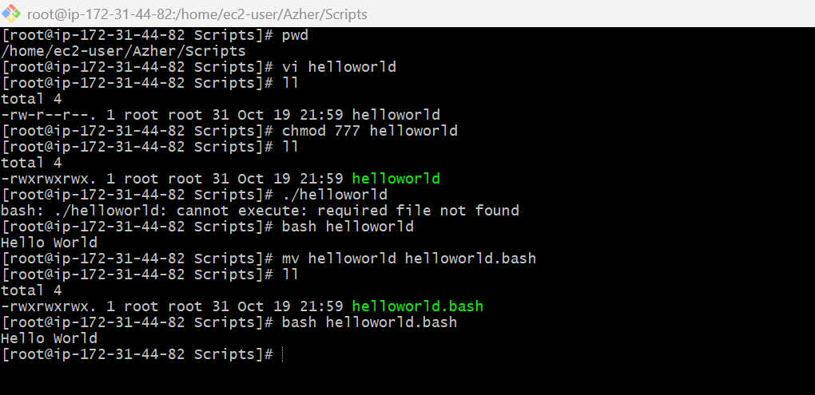
2 . Executing bash file from absolute path
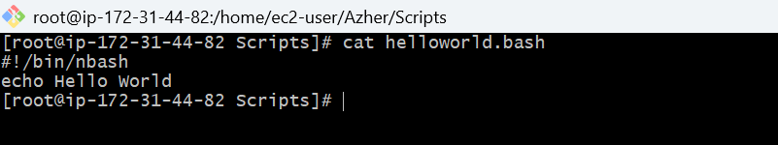
3 . Executing bash file from relative path
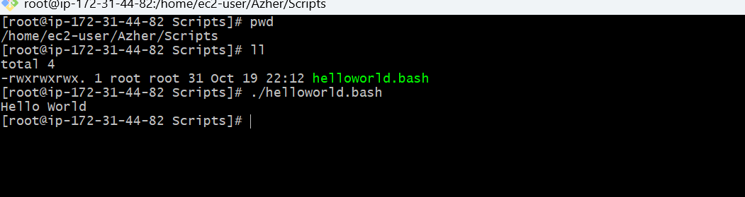
4 . Basic bash scripting with some basic commands
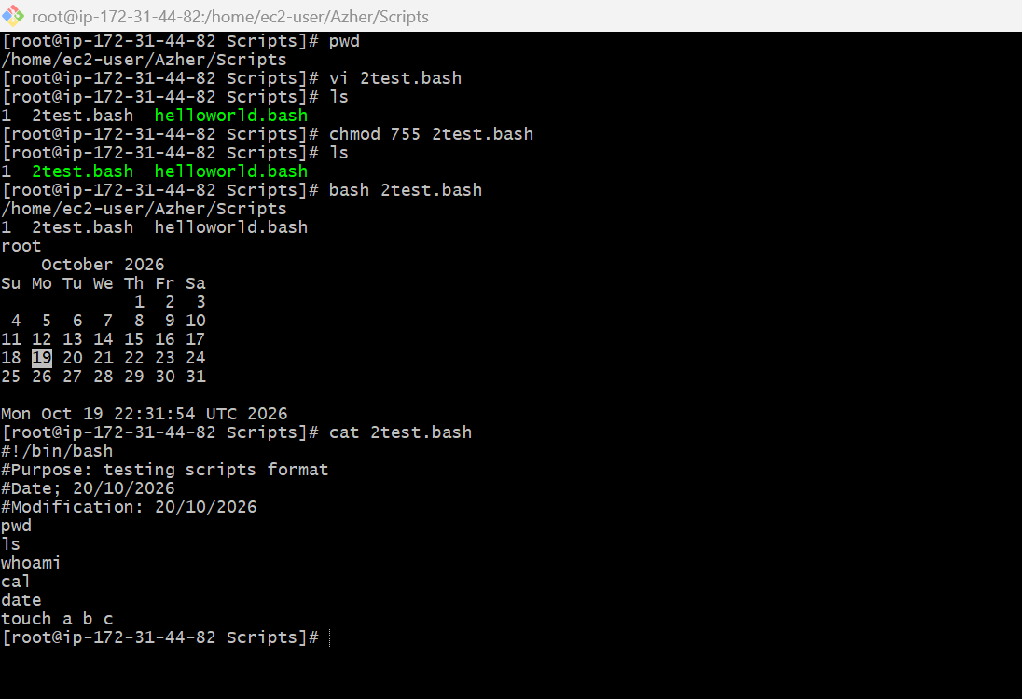
5 . Bash scripting for some admin tasks
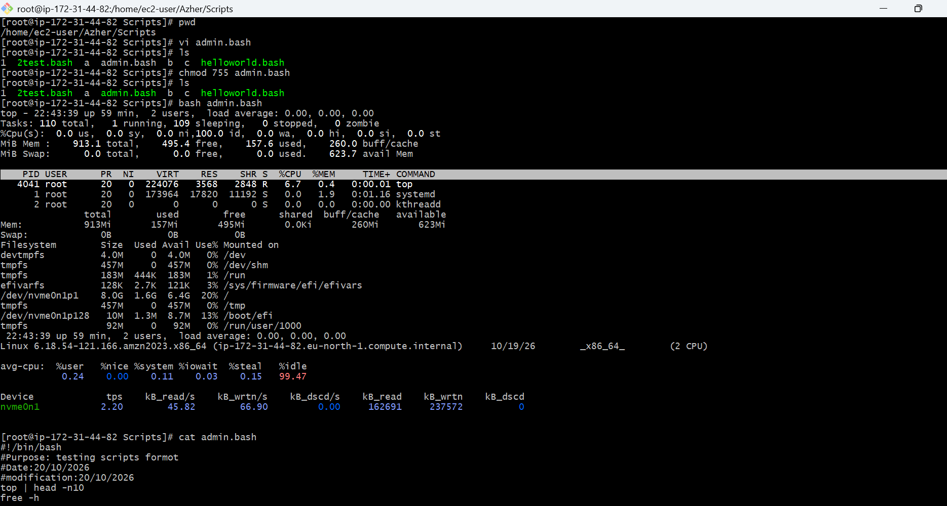
6 . Basic bash scripting with variables
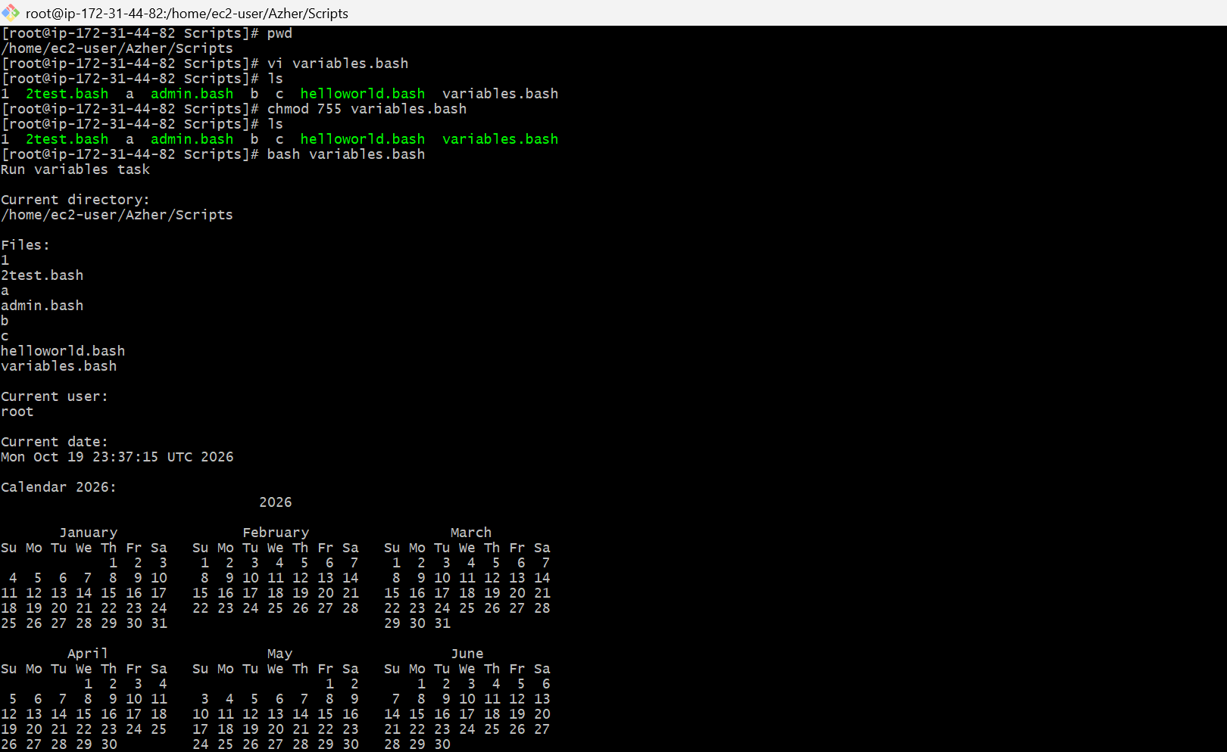
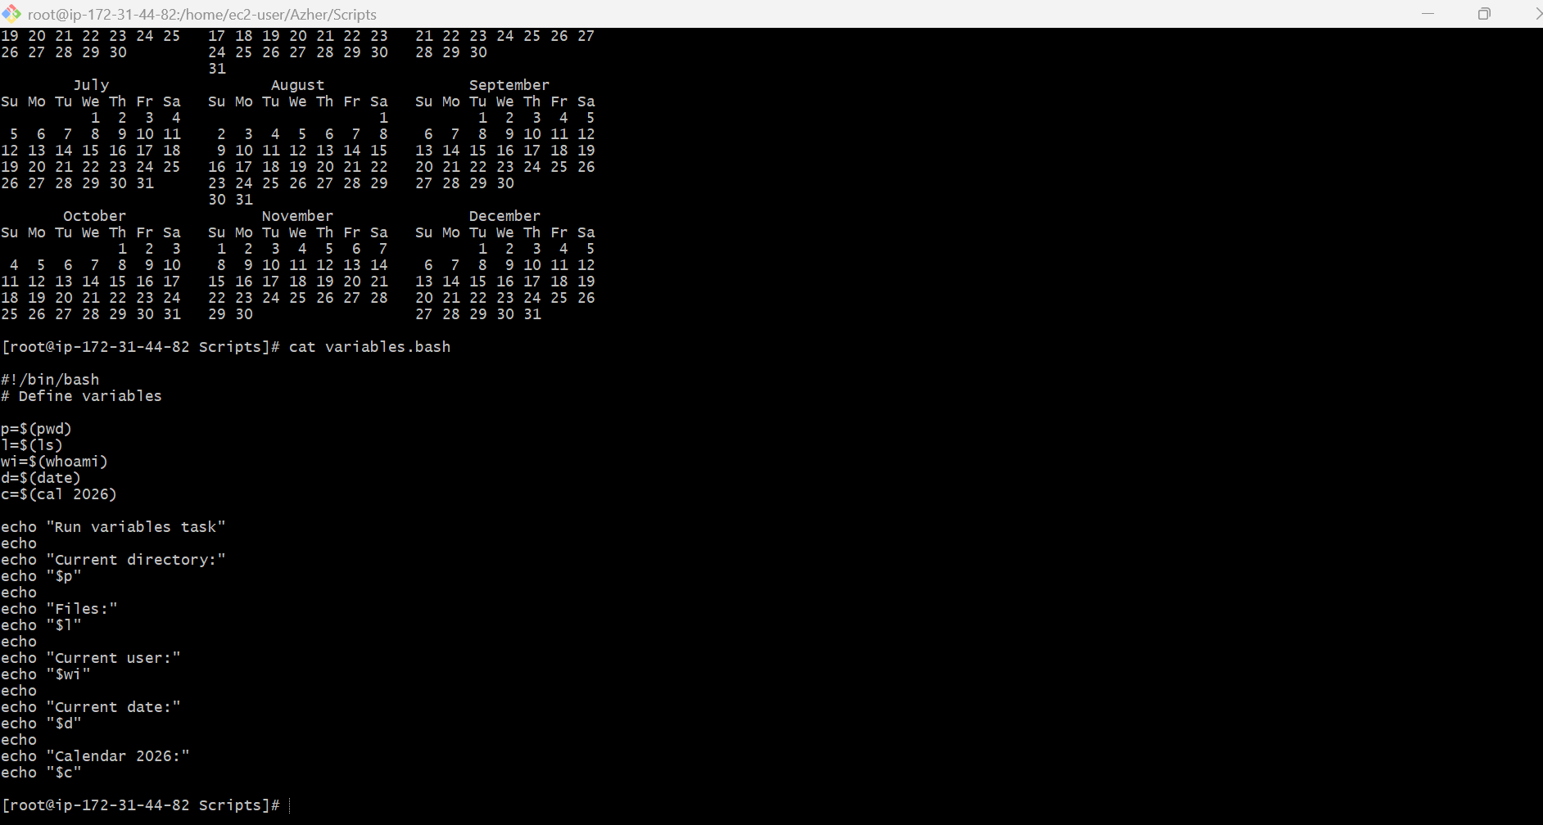
7 . Input/Output bash scripting
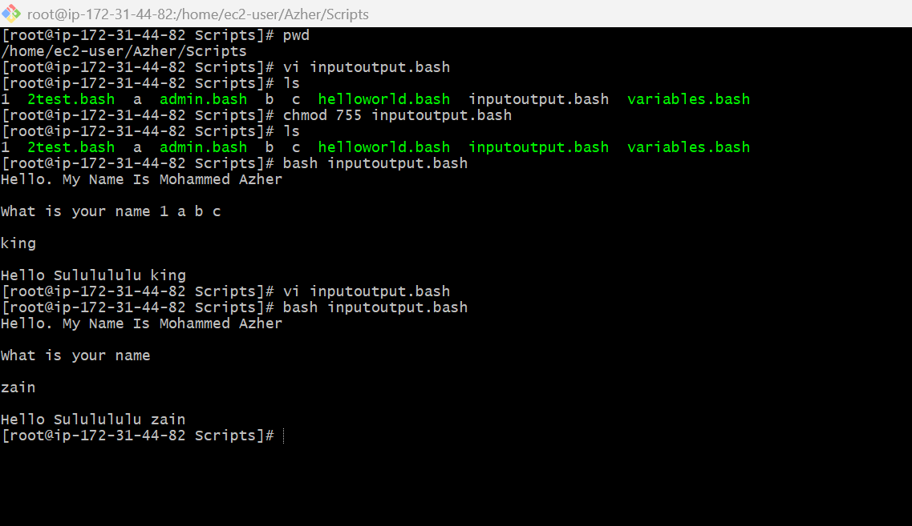
8 . Input/Output bash scripting with variables